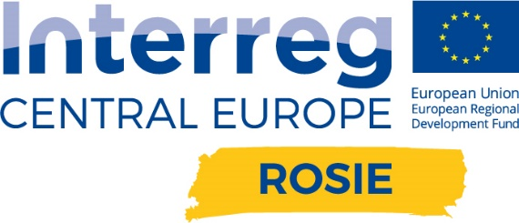

ROSIE – Responsible and Innovative SMEs in Central Europe

Disscussion PANEL
4th aPRIL 2019

April 4th 2019
Arena Lublin, Stadionowa 1, Lublin
09:00 – 10:00 | Opening Ceremony Innovation in Practice –  panel meetings 2019  - Welcome and introduction to the conference  - Key note speech: Ms Giula Bubbolini Bringing responsible innovation closer to SMEs: the Interreg CE ROSIE experience (9:30 – 9:45)  - Inaugural lecture: Mr Ph.D. Mariusz Krawiec, prof. UMCS Silicen - an innovative material of future nanoelectronics (9:45 – 10:00)
10:00 – 10:30 Coffee Break
10:30 – 13:30 | ROSIE Discussion Panel:  - Pilot Action in PP11: Ms Joanna Rzeszutek BIOTOP,  Mr Jan Góźdź EUREKAINZ, Mr Jakub Partyka INDUSTI  - Social repsonsibility – case study: Azoty S.A. Ms Monika Płońska, Mr Marek Sieprawski  - A representative of one of the ROSIE PPs
13:30 – 14:30 Lunch Break
14:30 – 16:00 | Visiting VIII Exhibition of Innovative Solutions and New Technologies

